# Forward Kinematics

### Theoretical Solution

The Forward Kinematics analysis derives the relationship between the individual joints of the robot manipulator and the position and orientation of the tool or end-effector. The joint variables are the angles between the links in the case of revolute or rotational joints,

# Forward Kinematics

:

*Ai* = *Rotz,θi TransZ,di Transx,ai Rotx,αi*

 

*Cθi −sθicαi sθicαi aθicθi*

 

= *sθi cθicαi −cθisαi aθisθi*

 

0 *sαi cαi di*

0 0 0 1

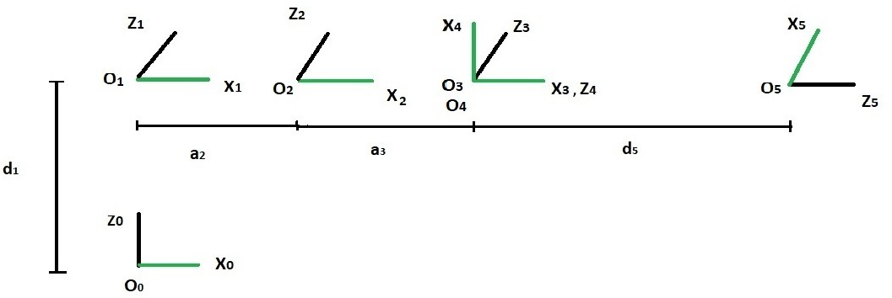

Coordinate frame assigned to 5 DOF Manipulator

The DH parameters obtained for our manipulator after assigning Coordinate frames as per DH convention is :

|  |  |  |  |  |
| --- | --- | --- | --- | --- |
| Link(i) | *αi* | *ai* | *di* | *θi* |
| 1 | -90 | 0 | *d*1 | *θ*1 |
| 2 | 0 | *a*2 | 0 | *θ*2 |
| 3 | 0 | *a*3 | 0 | *θ*3 |
| 4 | *−*90 | 0 | 0 | *θ*4 *−* 90 |
| 5 | 0 | 0 | *d*5 | *θ*5 *−* 90 |

DH Parameters

*T*5 = *A*1*A*2*A*3*A*4*A*5

*c*1*c*234*c*5 + *s*1*s*5 *−c*1*c*234*s*5 + *s*1*c*5 *−c*1*s*234 *c*1(*−d*5*s*234 + *a*3*c*23 + *a*2*c*2)

*T* = *c*1*c*234*c*5 *− s*1*s*5 *−s*1*c*234*s*5 *− c*1*c*5 *−s*1*s*234 *s*1(*−d*5*s*234 + *a*3*c*23 + *a*2*c*2)

5



*−s*234*c*5 *s*234*s*5 *−c*234 *d*1 *− a*2*s*2 *− a*3*s*23 *− d*5*c*234 

0 0 0 1

(3)

Where *Cijk* = *cos*(*θi* + *θj* + *θk*)*, sijk* = *sin*(*θi* + *θj* + *θk*)*.*

From *T*5 one can obtain the position of end effector as :

*c*1(*−d*5*s*234 + *a*3*c*23 + *a*2*c*2)

and orientation as :

*P*5 =

*s*1(*−d*5*s*234 + *a*3*c*23 + *a*2*c*2) *d*1 *− a*2*s*2 *− a*3*s*23 *− d*5*c*234

(4)

*O*5 =

*c*1*c*234*c*5 + *s*1*s*5 *−c*1*c*234*s*5 + *s*1*c*5 *−c*1*s*234

*c*1*c*234*c*5 *− s*1*s*5 *−s*1*c*234*s*5 *− c*1*c*5 *−s*1*s*234

 

*−s*234*c*5 *s*234*s*5 *−c*234

(5)

|  |  |  |
| --- | --- | --- |
| *x*5*y* | = *c*1*c*234*c*5 *− s*1*s*5 | (7) |
|  | *x*5*z* = *−s*234*c*5 | (8) |
| *y*5*x* | = *−c*1*c*234*s*5 + *s*1*c*5 | (9) |
| *y*5*y* | = *−s*1*c*234*s*5 *− c*1*c*5 | (10) |
|  | *y*5*z* = *s*234*s*5 | (11) |
|  | *z*5*x* = *−c*1*s*234 | (12) |
|  | *z*5*y* = *−s*1*s*234 | (13) |
|  | *z*5*z* = *−c*234 | (14) |

*p*5*x* = *c*1(*−d*5*s*234 + *a*3*c*23 + *a*2*c*2) (15)

*p*5*y* = *s*1(*−d*5*s*234 + *a*3*c*23 + *a*2*c*2) (16)

*p*5*z* = *d*1 *− a*2*s*2 *− a*3*s*23 *− d*5*c*234 (17) Now, we solve these equations for *θ*1*, θ*2*, θ*3*, θ*4*, θ*5 :

*θ* = *tan−*1 *p*5*y , where, p*

1

*p*

5*x*

*π π*

*>* 0 *or < θ <*

5*x*

2

1

2

(18)

*θ*2 = *atan*2,*a*(*a*2 + *a*3*c*3) *− ba*3*s*3*, aa*3*s*3 + *b*(*a*2 + *a*3*c*3), (19)

*a*2 + *b*2 *− a*22 *− a*32

*θ*3 = *arccos*

(20)

2*a*2*a*

3

Where, *a* = *d*1 *− d*5*c*234 *− p*5*z* and *b* = *p*5*xc*1 + *p*5*ys*1 + *d*5*s*234

*θ*4 = *c*23 *− θ*2 *− θ*3 (21)

*θ*5 = *c*234*θ*1 *−* 2*atan*(*x*5*y, x*5*x*) (22)

|  |  |  |
| --- | --- | --- |
| *x*5*y* | = *c*1*c*234*c*5 *− s*1*s*5 | (7) |
|  | *x*5*z* = *−s*234*c*5 | (8) |
| *y*5*x* | = *−c*1*c*234*s*5 + *s*1*c*5 | (9) |
| *y*5*y* | = *−s*1*c*234*s*5 *− c*1*c*5 | (10) |
|  | *y*5*z* = *s*234*s*5 | (11) |
|  | *z*5*x* = *−c*1*s*234 | (12) |
|  | *z*5*y* = *−s*1*s*234 | (13) |
|  | *z*5*z* = *−c*234 | (14) |

*p*5*x* = *c*1(*−d*5*s*234 + *a*3*c*23 + *a*2*c*2) (15)

*p*5*y* = *s*1(*−d*5*s*234 + *a*3*c*23 + *a*2*c*2) (16)

*p*5*z* = *d*1 *− a*2*s*2 *− a*3*s*23 *− d*5*c*234 (17) Now, we solve these equations for *θ*1*, θ*2*, θ*3*, θ*4*, θ*5 :

*θ* = *tan−*1 *p*5*y , where, p*

1

*p*

5*x*

*π π*

*>* 0 *or < θ <*

5*x*

2

1

2

(18)

*θ*2 = *atan*2,*a*(*a*2 + *a*3*c*3) *− ba*3*s*3*, aa*3*s*3 + *b*(*a*2 + *a*3*c*3), (19)

*a*2 + *b*2 *− a*22 *− a*32

*θ*3 = *arccos*

(20)

2*a*2*a*

3

Where, *a* = *d*1 *− d*5*c*234 *− p*5*z* and *b* = *p*5*xc*1 + *p*5*ys*1 + *d*5*s*234

*θ*4 = *c*23 *− θ*2 *− θ*3 (21)

*θ*5 = *c*234*θ*1 *−* 2*atan*(*x*5*y, x*5*x*) (22)

